

East West University

Department of Computer Science & Engineering

**Course Title:** Database System

**Course Code:** CSE301  
**Experiment No:** 10

**Semester:** Fall, 2015

**Section:** 01

**Submitted By:**

S. M. Amirul Islam

ID: 2013-1-60-048

**Lab Works**

**Problem:**

The tables are as follows

|  |  |
| --- | --- |
| **Deptid** | **Dept name** |
| 60 | CSE |
| 10 | BBA |
| 80 | EEE |
| 40 | ETE |
| 50 | ECE |

|  |  |  |  |
| --- | --- | --- | --- |
| **Ins id** | **Ins name** | **Salary** | **Dept id** |
| 101 | ABC | 44000 | 60 |
| 102 | XYZ | 66000 | 60 |
| 103 | ASD | 101871 | 60 |
| 201 | EFG | 40000 | 10 |
| 202 | MNO | 60000 | 10 |
| 301 | HIJ | 88000 | 80 |
| 302 | LMN | 44000 | 80 |
| 401 | PQR | 60000 | 50 |
| 402 | FGH | 50000 | 50 |
| 501 | GHL | 40000 | 40 |
| 502 | XCV | 60000 | 40 |

1. Update the instructor salary 10% of a specific dept.

SQL: create procedure update_salary @deptname1 varchar(10)

as

begin

update instructor set salary=salary*1.10

where dept_id=(select dept_id from dept where dept_name=@deptname1)

end

exec update_salary'CSE'

select*from instructor

Output Screenshot after update: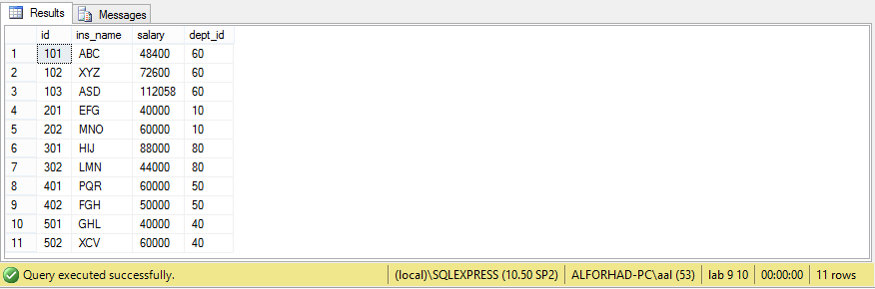

1. Write a function to get the department by its id.

SQL:create function getname(@id int)

returns varchar(10)

as

begin

declare @d_name varchar(10)

select @d_name=dept_name from dept where dept_id=@id

return @d_name

end

select dbo.getname(60)

Output Screenshot: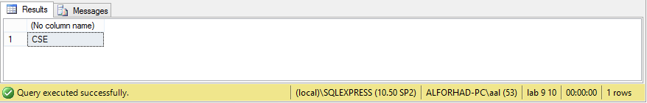

1. Write a function where instructor id is given, which returns salary.

SQL:create function getsalary(@insid int)

returns int

as

begin

declare @sal int

select @sal=salary from instructor where @insid=id

return @sal

end

select dbo.getsalary(103)

Output Screenshot: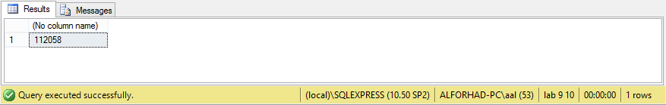

1. If salary>=50000 print “His salary is high” else print “His salary is low”

SQL: declare @sal2 int

select @sal2 = dbo.getsalary(103)

if @sal2>=50000

print'His salary is high'

else

print'His salary is low'

Output Screenshot: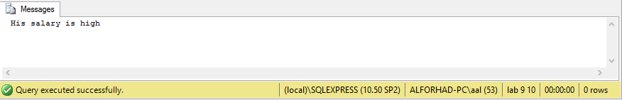

1. If salary > 50000 then 5% increment else 10% increment.

SQL: declare @sal3 int

select @sal3=dbo.getsalary(103)

if @sal3>50000

begin

update instructor set salary=@sal3*1.05 where id=103

end

else

begin

update instructor set salary=@sal3*1.1 where id=103

end

select*from instructor

Output Screenshot after update: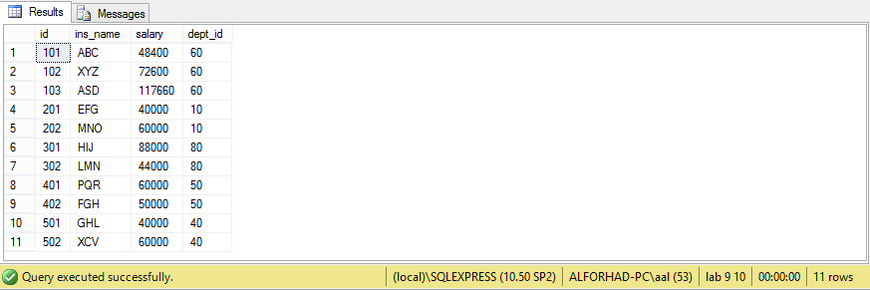

1. Write a function to return the total salary of two instructors by their id.

SQL: create function calsalary(@id1 int,@id2 int)

returns int

as

begin

declare @sal4 int

select @sal4=(T.salary + S.salary)

from instructor as T, instructor as S where T.id=@id1 and S.id=@id2

return @sal4

end

select dbo.calsalary(401,402)

Output Screenshot: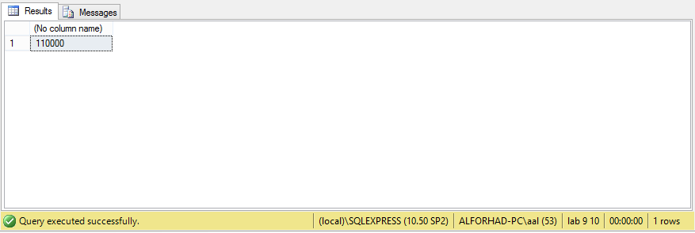

1. Print all instructors ID.

SQL: declare @allinsid cursor

set @allinsid =cursorforselect id from instructor

declare @insid int

open @allinsid

fetch next from @allinsid into @insid

while@@FETCH_STATUS=0

begin

print @insid

fetch next from @allinsid into @insid

end

close @allinsid

deallocate @allinsid

Output Screenshot: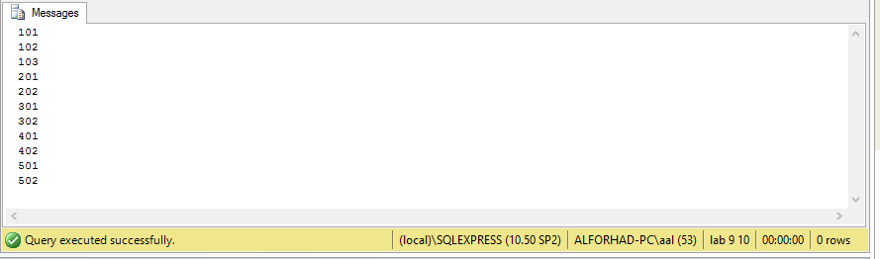

1. Print all Dept name.

SQL: declare @alldeptname cursor

set @alldeptname =cursorforselect dept_name from dept

declare @deptname varchar(10)

open @alldeptname

fetchnextfrom @alldeptname into @deptname

while@@FETCH_STATUS=0

begin

print @deptname

fetchnextfrom @alldeptname into @deptname

end

close @alldeptname

deallocate @alldeptname

Output Screenshot: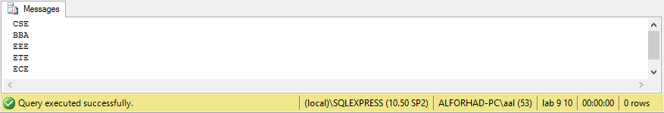

1. Print all salary.

SQL: declare @allsalary cursor

set @allsalary =cursorforselect salary from instructor

declare @ssal varchar(10)

open @allsalary

fetchnextfrom @allsalary into @ssal

while@@FETCH_STATUS=0

begin

print @ssal

fetchnextfrom @allsalary into @ssal

end

close @allsalary

deallocate @allsalary

Output Screenshot: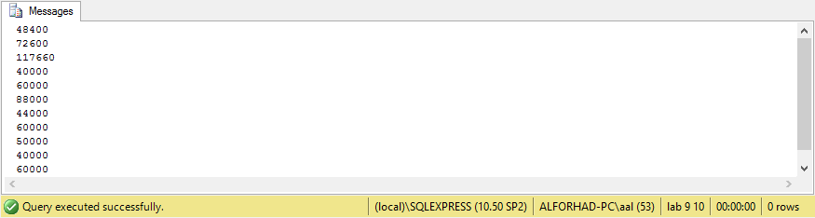

**Discussion:**

At the end of this LAB I have learned the use of function in database systems using SQL commands.